Aspen Blue Koreny-Crawford

Southern New Hampshire University

CS 340 Client/Server Development

20 February 2025

Grazioso Salvare Dashboard README

Overview

This project provides an interactive MongoDB-backed dashboard for Grazioso Salvare to filter and visualize the Austin Animal Center Outcomes data. The dashboard uses Dash (Plotly) and dash_leaflet to display:

* A data table that updates based on rescue-type filters
* A pie chart (or second chart of choice)
* A Leaflet map showing a marker for the selected animal

It follows an MVC pattern:

* Model: MongoDB database
* View: Dash UI (data table, chart, map)
* Controller: A Python CRUD module connecting Dash callbacks to MongoDB.

Required Functionality

1. Filtering (radio buttons) for “Water Rescue,” “Mountain/Wilderness Rescue,” “Disaster/Individual Tracking,” or “Reset.”
2. Data Table showing unfiltered data by default, then filtered results.
3. Pie Chart that displays top breeds from the filtered data.
4. Geolocation Map that pins the selected row’s latitude/longitude.
5. Grazioso Salvare logo and a unique identifier on the dashboard.

Tools Used

* MongoDB: Stores animal outcomes data, easy Python integration.
* Dash/Plotly: Builds the interactive web app in pure Python.
* dash_leaflet: Displays location markers for each selected animal.
* CRUD Module: Encapsulates MongoDB queries (read, filter) for the dashboard.

Steps to Reproduce

1. Set Up MongoDB: Import aac_shelter_outcomes.csv into aac.animals. Create user aacuser with read/write.
2. Install:
   1. pip install dash dash_leaflet plotly pymongo pandas
3. Run: Place ProjectTwoDashboard.ipynb, crud_module.py, and the Grazioso Salvare Logo in one folder. Open and run ProjectTwoDashboard.ipynb.
4. Browse: Go to the printed link (e.g., 127.0.0.1:8050).

1. Test: Choose each rescue type filter, confirm table, chart, and map update.

Challenges

* Authentication: Ensuring files were correctly communicating so that username/password worked.
* Column Indices: Ensured lat/long columns exist for the map marker.
* Pie Chart Overload: Grouped by breed at first and had a visual glitch, and limited top 10.

**Screenshots**

1. **Starting (Unfiltered)**

1. **Water Rescue**

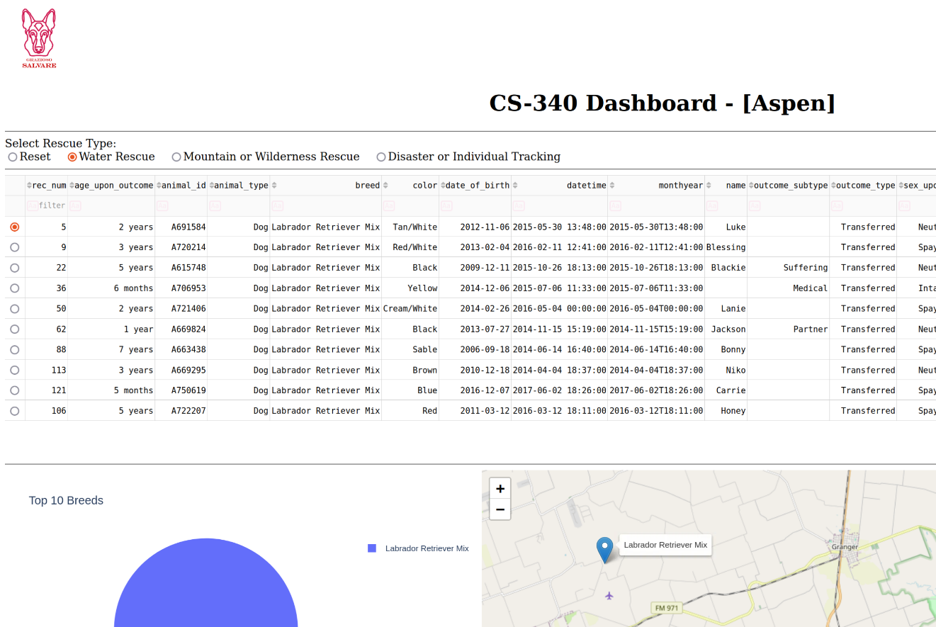

1. **Mountain/Wilderness**

1. **Disaster/Individual**

1. **Reset**

